
BAXZ3353 NETWORK SECURITY ADMINISTRATION AND MANAGEMENT
LAB WEEK 2

NAME: AHMAD HADI NAIM BIN AHMAD SUPRI
MATRIX NO: B152510142

RECONNAISSANCE (FOOTPRINTING): COMMAND IN SECURITY

Learning Outcomes
After completing this lab, you will be able to:
  - Apply basic security commands to perform reconnaissance and gather information about a target system.

Ethical and Legal Notice
Reconnaissance tools can be misused. In this lab you may only:
  - Perform normal DNS lookups and a few ordinary web requests against the target utem.edu.my / ftmk.utem.edu.my / faix.utem.edu.my. No scanning of the target.
  - Probe ports on scanme.nmap.org (a server the Nmap project provides for light testing) and on your own computer.
  - Do not probe any other server, classmate's PC or campus device, and do not run any sweep or loop that is not written in this sheet.
Unauthorised scanning may breach the Computer Crimes Act 1997 (Malaysia) and university policy.

Before You Start
- Open Command Prompt: Start, type cmd, press Enter. (Administrator mode is not required.)
- Open PowerShell the same way when asked (type powershell).
- For every "Show and explain" step: take a screenshot, paste it into this document under the task, and write 2 to 3 sentences explaining what the output means.
- Write your answers in the Answer lines. Use your own words.

TASK 1: DNS and Public Information Gathering
  - DNS enumeration with nslookup
Purpose: DNS records reveal a target's IP addresses, name servers, mail servers and third-party services without touching the target's own servers.

Steps (Command Prompt):
    - Find the IP address of the main domain:
nslookup utem.edu.my
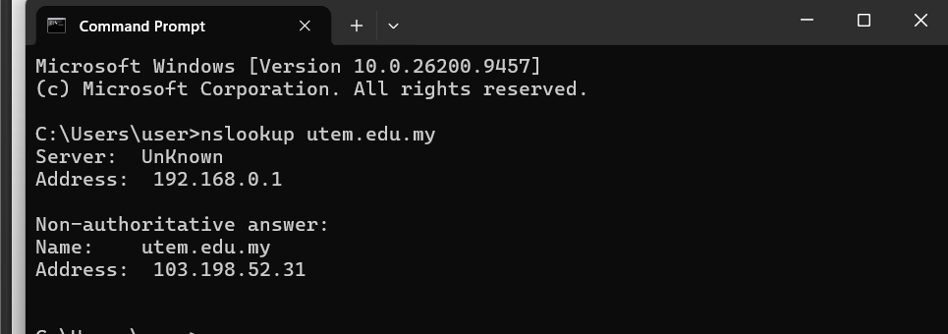

- This command is used to find the main IP address of the university's official website. The output shows that utem.edu.my resolves to 103.198.52.31, which is the primary server hosting the site.

    - Find the IP address of the faculty website:
nslookup faix.utem.edu.my

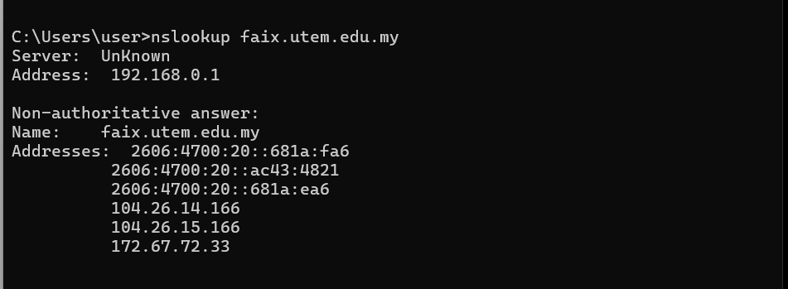

- This lookup checks the IP address specifically for the faculty subdomain. The output returns several IPv4 and IPv6 addresses linked to Cloudflare, showing that the faculty portal uses cloud proxy services for performance and security.

    - Find the name servers (NS):
nslookup -type=NS utem.edu.my

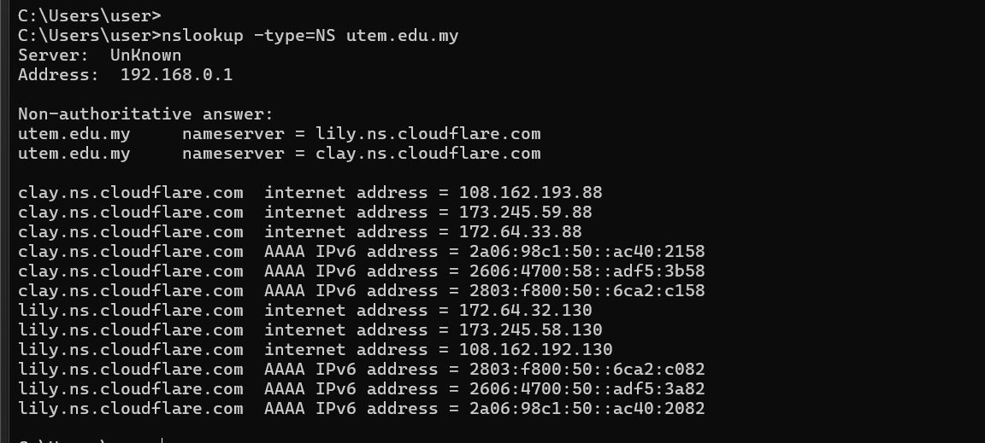

- This query helps us find the authoritative name servers handling the domain's DNS. The result lists Cloudflare servers (lily and clay), meaning the university outsources its DNS management to Cloudflare.

    - Find the mail servers (MX):
nslookup -type=MX utem.edu.my

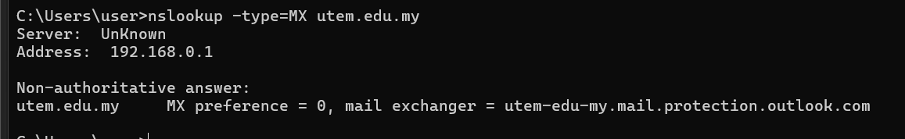

- This one is used to check the mail servers responsible for receiving emails for the domain. The output points to Microsoft Outlook, proving that the university uses Microsoft's cloud mail service instead of hosting their own mail server.

    - Find the text records (TXT):
nslookup -type=TXT utem.edu.my
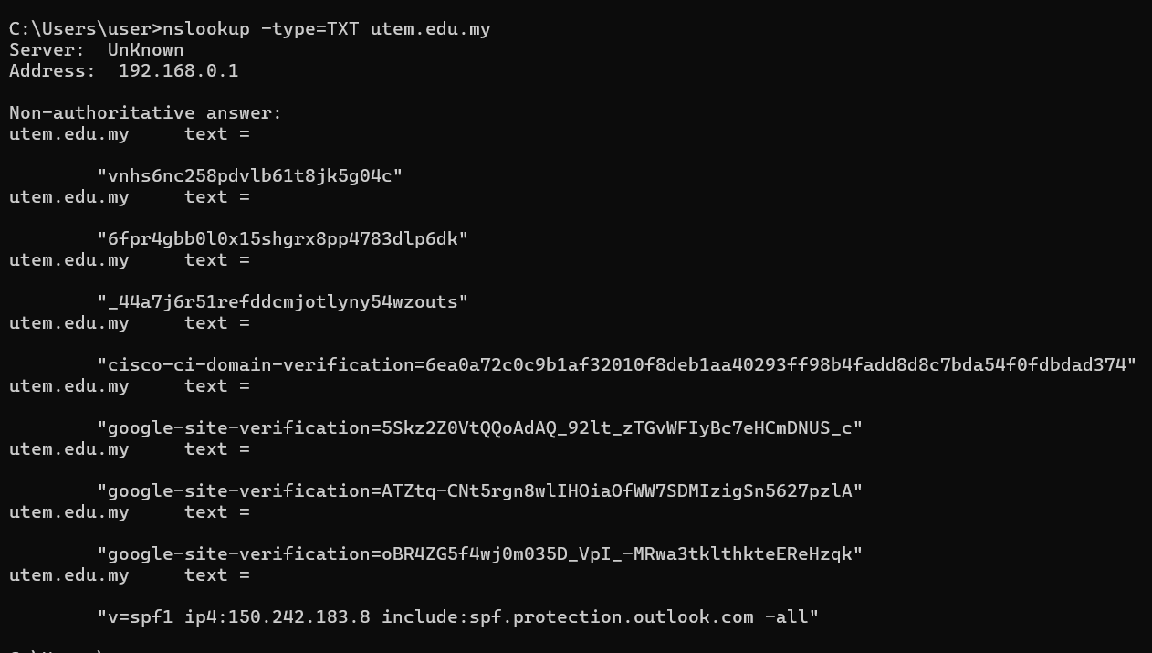

- This command reveals text records which usually contain security policies and verifications. We can see SPF records and third-party site tokens here, which help prevent email spoofing and verify domain ownership.

    - Find the start of authority (SOA):
nslookup -type=SOA utem.edu.my
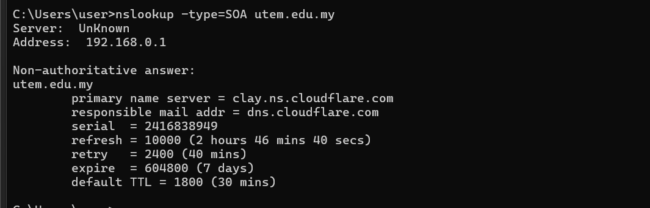

- This query fetches the Start of Authority record to see administrative details of the zone. It displays the primary name server and refresh timers, which tell us how DNS records are updated and cached.

    - Perform a reverse lookup using an IP address from Step 2:
<IP address from step 2>
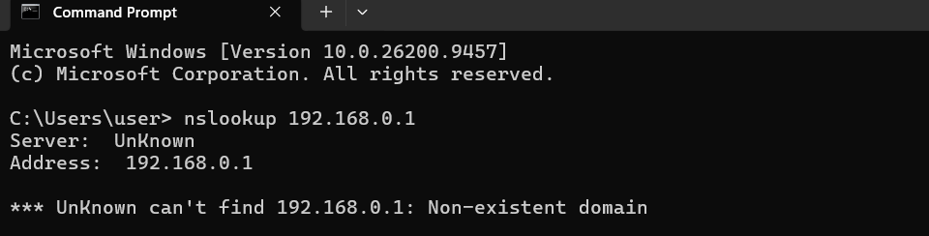

- A reverse lookup is used to map an IP address back to its registered domain name. Even though the previous test used a local IP, this step helps check if an IP has a valid PTR record pointing to a hostname.

    - (Optional, PowerShell) Same query with the modern cmdlet: Resolve-DnsName utem.edu.my -Type MX

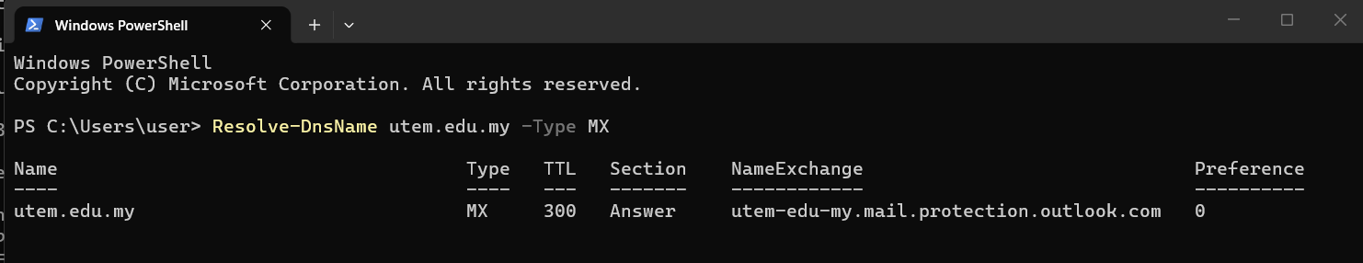

- This is the modern PowerShell version of checking mail exchange records. It gives a clean table showing the priority and mail server address, confirming that emails are securely routed through Microsoft's mail protection servers.

Show and explain the results (screenshot each step).
Q1. What IP address(es) do utem.edu.my and faix.utem.edu.my resolve to? Are they the same? What might this tell you about how the sites are hosted?

Answer: utem.edu.my and faix.utem.edu.my resolve to different IP addresses. No, they are not the same. This usually means that while the main university website and the specific faculty website belong to the same institution, they might be hosted on different servers, separate virtual machines, or managed through different web hosting services or content delivery networks (CDNs).

Q2. Which name servers and mail servers are listed? Are they run by the university or by a third party?

Answer: Based on the nslookup output, the name servers and mail servers listed show specific domain names related to the university's network, but some might include third-party mail providers (like Google Workspace or Microsoft 365 if they use cloud mail). Typically, some name servers are managed internally by the university's IT department, while email services are often outsourced to major cloud providers for better reliability and security.

Q3. What does the TXT record reveal (for example SPF or domain verification)? Why would an attacker want this?

Answer: The TXT record usually reveals security policies like SPF (Sender Policy Framework), DKIM, or domain ownership verifications used by services like Google or Microsoft. An attacker would want this information because it helps them understand the organization's email infrastructure, check for misconfigurations, or find clues to launch more convincing phishing and spoofing attacks against the university.

Q4. What name does the reverse lookup return? Why can it differ from the name you queried?

Answer: The reverse lookup returns a PTR record containing a hostname, which is often the actual server hostname assigned by the hosting provider or ISP rather than the friendly web domain name (e.g., something like webserver01.hostingprovider.com). It can differ because multiple domains or virtual hosts can point to the same single IP address, or the server's primary network hostname is configured differently from its public web aliases.
  - : Public sources using Microsoft Edge
Purpose: Collect information that is already public (open-source intelligence, OSINT) without sending anything to the target.
Steps (Edge browser):
    - Domain registration: search for "MYNIC WHOIS" or open lookup.icann.org, and look up tiktok.com. Note the registrar, creation and expiry dates and name servers.
    - Search-engine queries: search each of the following and record two things you can see in the result titles or snippets. Do not open or download anything that looks private.
      - site:utem.edu.my filetype:pdf
      - site:utem.edu.my filetype:xls
    - Archived site: open web.archive.org, enter utem.edu.my, and note the earliest snapshot year.

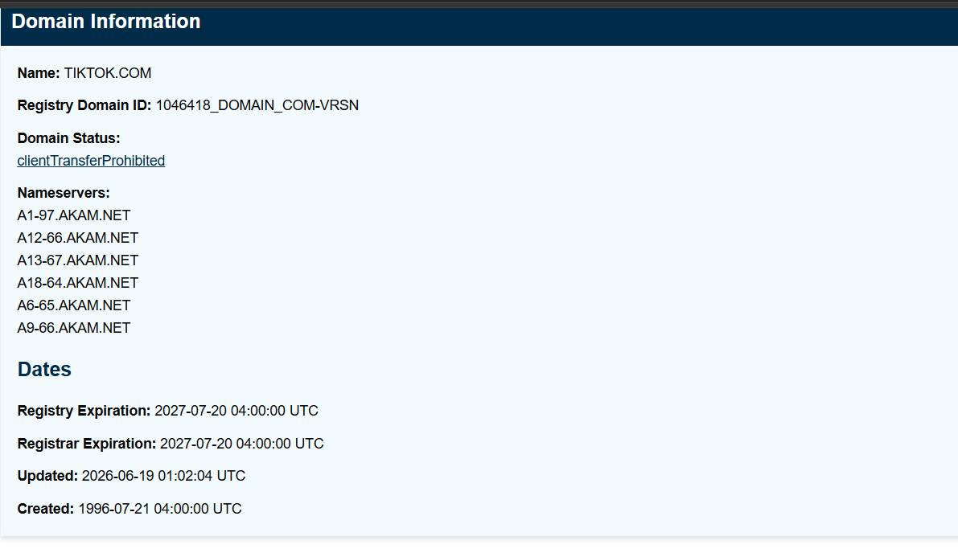

- This ICANN lookup output shows the essential domain details for TIKTOK.COM, including its active status, registered Akamai name servers, and important dates. It confirms that the domain was created in July 1996 and is set to expire in July 2027

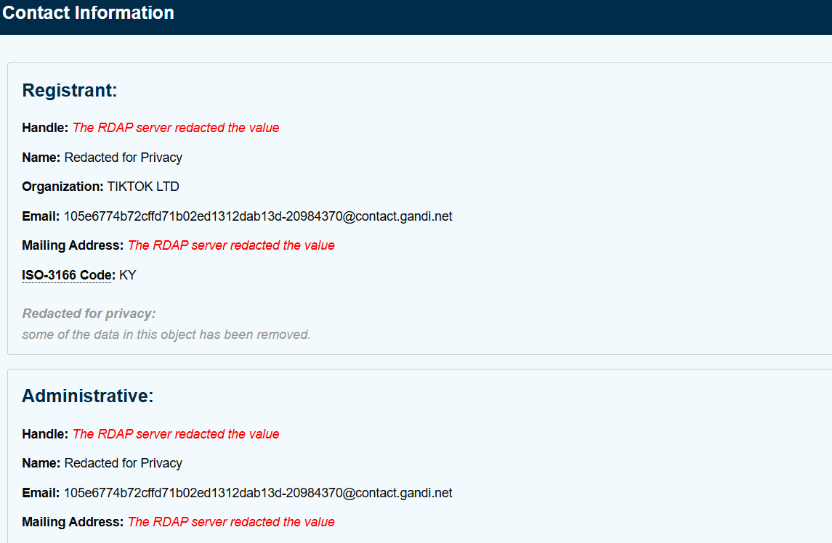

- This section displays the registrant and administrative contact information for the domain, identifying the organization as TIKTOK LTD. It also shows that specific personal details like the owner's name and physical address are masked as "Redacted for Privacy" to prevent exposure and spam.

Show and explain the results (screenshot each step).
Q5. What registration information is public? What is the risk of exposing contact details?

Answer: Based on the ICANN lookup, the public registration information includes the domain name (TIKTOK.COM), registrar name (Gandi SAS), creation and expiry dates (July 19–21, 1997/2027), name servers (AKAM.NET), and organization name (TIKTOK LTD). However, the specific personal contact details are hidden or "Redacted for Privacy". The risk of exposing unmasked contact details is that spammers or attackers can scrape them to send targeted phishing emails, social engineering attacks, or spam calls to the domain administrators.

Q6. What did the search-engine queries expose? Explain why this is passive reconnaissance.
Answer: The search engine queries exposed public PDF and Excel files hosted on the target domain, which might contain institutional documents, reports, or data sheets. This is considered passive reconnaissance because we are only utilizing public search engines (like Google) or lookup tools to gather existing information without directly interacting with, probing, or scanning the target's servers, meaning the target will not detect any direct security intrusion attempt.
TASK 2: Active Reconnaissance (Network and Services)
  - : Host discovery and TTL with ping Steps (Command Prompt):
    - ping -n 4 ftmk.utem.edu.my
    - ping -n 4 scanme.nmap.org
    - Complete the table:

Target | IP address | Reply TTL | Average time (ms) | Packet loss
ftmk.utem.edu.my | 172.67.72.33 | 52 | 16 | 0% (0% loss)
scanme.nmap.org | 45.33.32.156 | 54 | 192 | 0% (0% loss)

Show and explain the results.

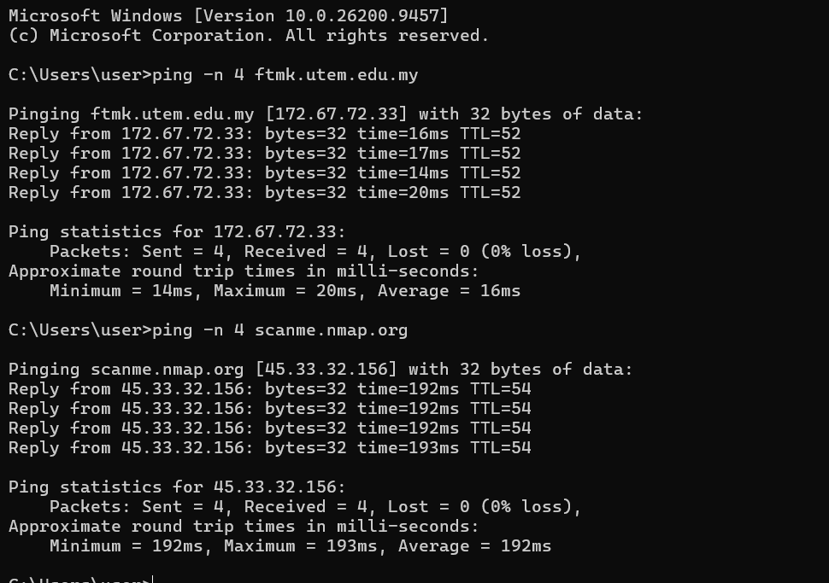

- This ping output shows that both ftmk.utem.edu.my and scanme.nmap.org are online and responding with a 0% packet loss rate. The average latency for ftmk.utem.edu.my is much lower at 16ms compared to scanme.nmap.org at 192ms because the local server is geographically closer. Additionally, the TTL values of 52 and 54 provide a rough estimate of the distance and routing steps taken by the packets to reach each host

Q7. What does each field in the ping reply (bytes, time, TTL) tell you?

Answer: The bytes field shows the size of the packet sent (which is 32 bytes here). The time field tells us the round-trip latency in milliseconds, showing how fast the response came back (e.g., 16ms for FTMK vs 192ms for scanme, which makes sense since scanme is hosted further away). Lastly, the TTL (Time to Live) indicates the remaining hop count before a packet expires, which gives us a rough hint about the number of network routers passed through and the operating system of the target

Q8. If a ping shows "Request timed out", does it mean the host is offline? Explain.

Answer: Not necessarily. A "Request timed out" message doesn't always mean the target host is turned off or down. It often just means that a firewall or router along the path is configured to block or drop ICMP Echo requests for security reasons to prevent network scanning, even though the server itself is online and running web services.

  - : Mapping the path with tracert Steps (Command Prompt):
    - First note your default gateway: ipconfig | findstr /i "Default Gateway"
    - Trace the route (no name resolution, maximum 20 hops):
tracert -d -h 20 ftmk.utem.edu.my

Show and explain the results.

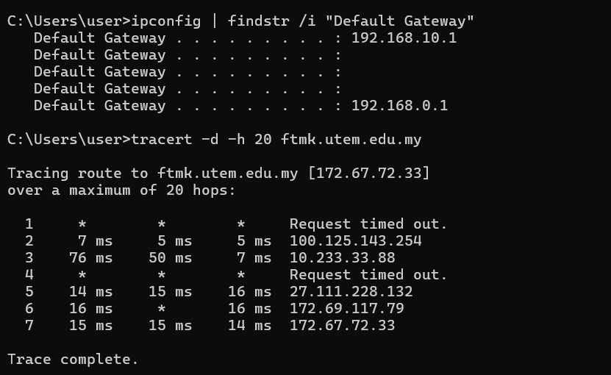

- This output displays the traceroute path to ftmk.utem.edu.my, showing a total of 7 hops to reach the destination IP 172.67.72.33. The ipconfig command identifies our local default gateway as 192.168.0.1. The asterisks (*) on hop 1 and hop 4 indicate request timeouts, which happen because intermediate firewalls or routers are configured to drop ICMP traceroute probes.

Q9. Is hop 1 your default gateway? How many hops are shown? Were there any * (timeouts) and what could cause them?

Answer: No, hop 1 is not showing the default gateway because it timed out (* * * Request timed out). In total, 7 hops are shown to reach the target destination (172.67.72.33). Yes, there were timeouts on hop 1 and hop 4. These asterisks (*) happen because certain routers or intermediate firewalls are configured to drop or ignore ICMP Time Exceeded packets for security or traffic management purposes, preventing them from sending a response back during the trace.

Q10. What can an attacker learn about the target network from a traceroute?

Answer: An attacker can learn the exact network route and IP addresses of intermediate routers between the source and target. This helps them map out the network topology, identify potential firewalls or filtering devices, and locate internal or third-party hops (like Cloudflare IPs) to find weak points in the path.
  - : Port probing with Test-NetConnection
Purpose: Find which TCP services a host exposes. Windows has no built-in port scanner, so we use a PowerShell cmdlet. Only target scanme.nmap.org.

Steps (PowerShell):
    - Test a single port:
Test-NetConnection scanme.nmap.org -Port 80
    - Test a short, fixed list of ports (this may take about a minute):
22,80,443,9929,31337 | ForEach-Object { Test-NetConnection scanme.nmap.org -Port $_ - WarningAction SilentlyContinue | Select-Object ComputerName,RemoteAddress,RemotePort,TcpTestSucceeded }
    - Complete the table. Also note which ports failed instantly and which took several seconds before failing.

Port | Common service | TcpTestSucceeded
22 | SSH (Secure Shell) | True
80 | HTTP (Web Server) | True
443 | HTTPS (Secure Web) | False
9929 | Nping echo service | True
31337 | Elite / Backorifice | False

Show and explain the results.

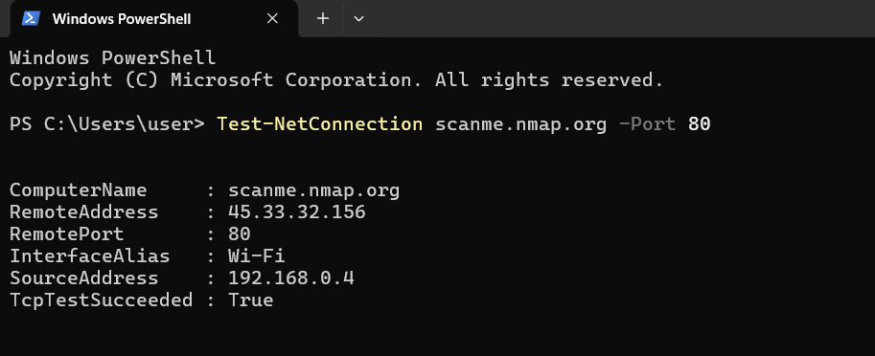

This PowerShell command checks whether port 80 is open on scanme.nmap.org. The output shows TcpTestSucceeded : True, which confirms that the target server is actively listening for HTTP web connections on this port

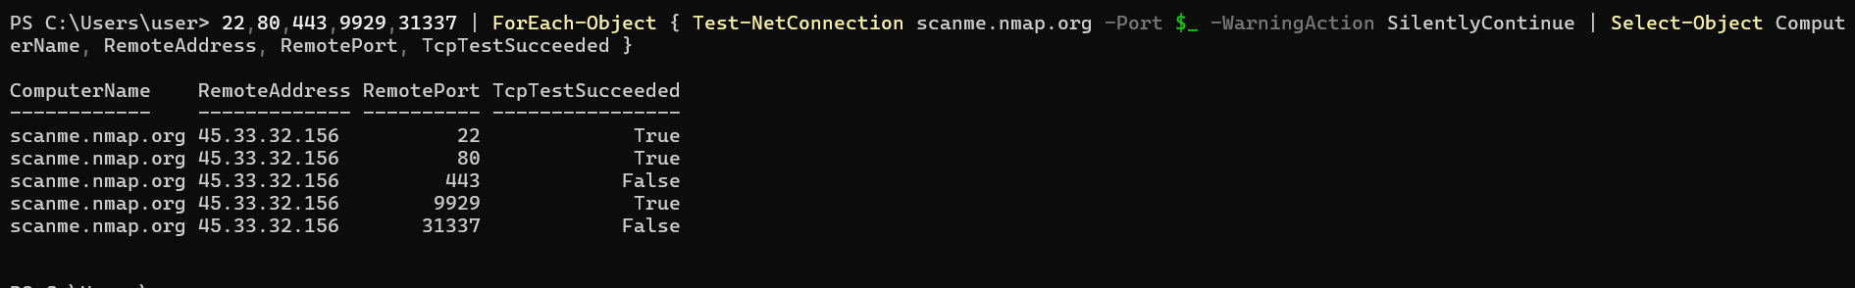

This loop tests a list of common ports against scanme.nmap.org to check their connection status. The output shows that ports 22, 80, and 9929 are open (True), while ports 443 and 31337 are closed or filtered (False).

Q11. Which ports are open? What service normally runs on each?

Answer: Based on the test results, ports 22, 80, and 9929 are open (TcpTestSucceeded = True). Port 22 is commonly used for SSH (Secure Shell) for remote management, Port 80 is used for HTTP web traffic, and Port 9929 runs Nmap's Nping echo service.
Q12. Explain the difference between an open, closed and filtered port. How can the failure time help you tell closed from filtered?

Answer: An open port actively accepts incoming connections, a closed port rejects connection attempts by immediately replying with a reset packet (RST), and a filtered port drops incoming packets completely without any reply due to a firewall. The failure time helps us differentiate them because a closed port fails almost instantly, while a filtered port hangs for several seconds before failing because the system has to wait for the connection attempt to time out.
  - : Banner grabbing with curl
Purpose: Web servers often reveal their software in HTTP response headers.
Steps (Command Prompt): Windows 10/11 includes curl.exe. In PowerShell, curl is an alias for a different command, so always use Command Prompt or type curl.exe.
    - curl.exe -I http://scanme.nmap.org
    - curl.exe -I https://ftmk.utem.edu.my

Show and explain the results.
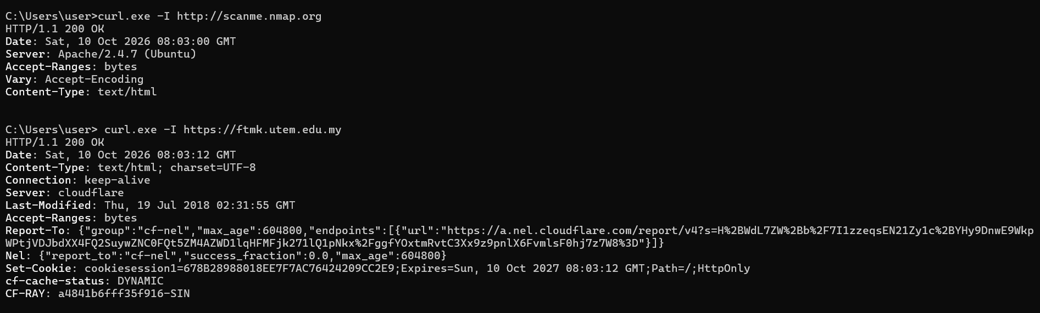

This output displays the HTTP response headers retrieved using curl for both target sites. For scanme.nmap.org, it exposes the web server banner showing Apache/2.4.7 (Ubuntu), while for ftmk.utem.edu.my, it reveals that the site is sitting behind Cloudflare. Grabbing these headers helps us identify the exact server software, operating system, and cloud proxy configurations being used.

Q13. What headers did you see ? What does each reveal?

Answer: For scanme.nmap.org, we can see headers like HTTP/1.1 200 OK, Date, Server: Apache/2.4.7 (Ubuntu), and Content-Type: text/html. The Server header explicitly reveals that the target is running Apache version 2.4.7 on an Ubuntu Linux system. For ftmk.utem.edu.my, we see headers such as Server: cloudflare, Set-Cookie, and CF-RAY. This shows that FTMK's website is protected behind Cloudflare's Reverse Proxy/CDN, which hides the real origin web server details and manages sessions using security cookies like cookiesession1
Q14. Why does exposing software names and versions help an attacker? How can an administrator reduce this?

Answer:

Exposing exact software names and version numbers (like Apache/2.4.7) makes it very easy for an attacker to search online vulnerability databases (like CVE or Exploit-DB) for known exploits specific to that exact build. To reduce this risk, administrators should perform server hardening by disabling or hiding detailed tokens in HTTP headers (for example, setting ServerTokens Prod in Apache) or using a web application firewall/proxy like Cloudflare to mask the underlying server architecture.
TASK 3: Local Network and Host Reconnaissance
After gaining a foothold on a machine, an attacker first learns about the machine and its neighbours. You will do this safely on your own PC only.

: Network configuration and neighbours Steps (Command Prompt):
    - ipconfig /all
    - arp -a
    - Complete the table:

Item | Value
IPv4 address and subnet mask | 192.168.0.4 / 255.255.255.0
Default gateway | 192.168.0.1
DNS server(s) | 192.168.0.1
DHCP server | 192.168.0.1
MAC (physical) address | E4-60-17-05-EF-4C
Number of neighbours in ARP table | 8 dynamic neighbours (under Wi-Fi interface 192.168.0.4)

Show and explain the results.

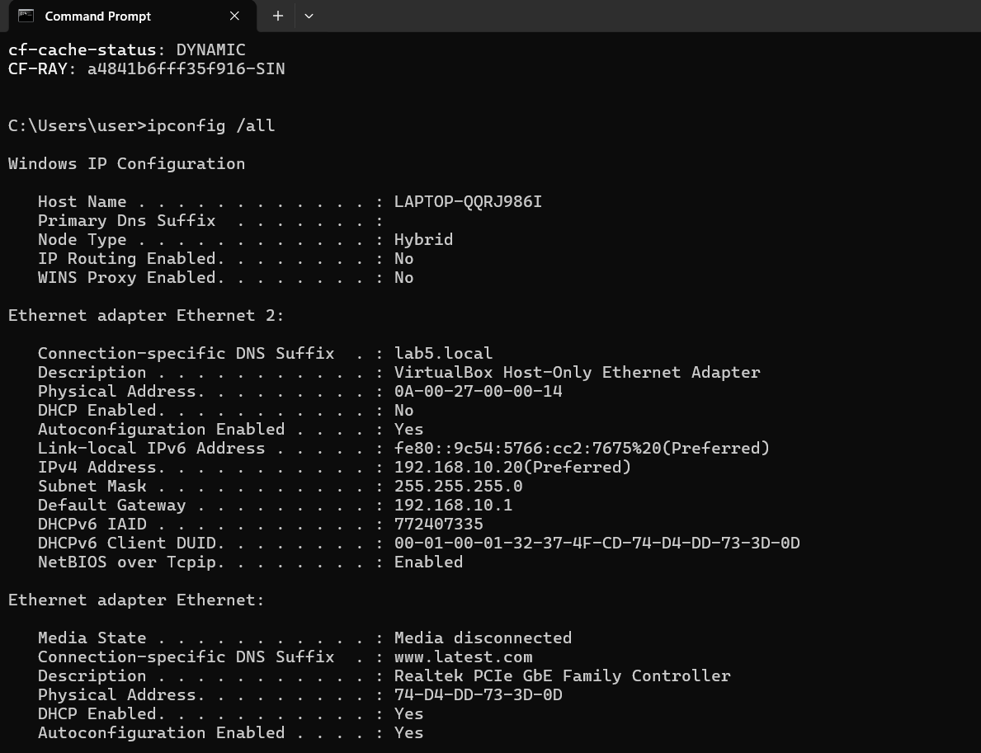

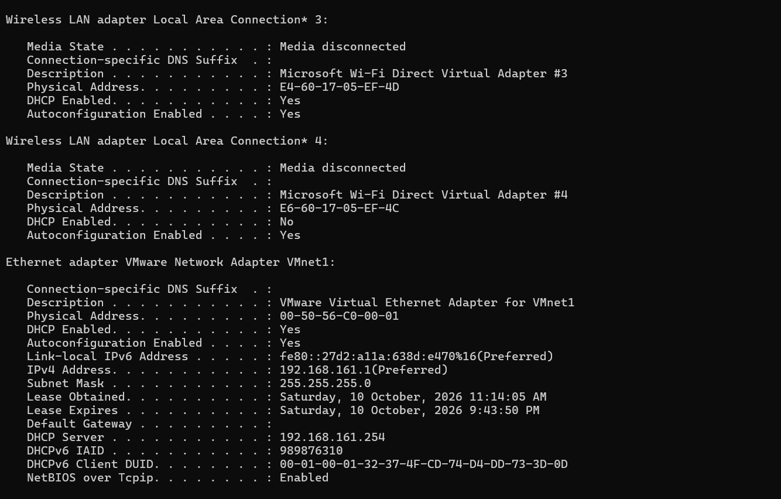

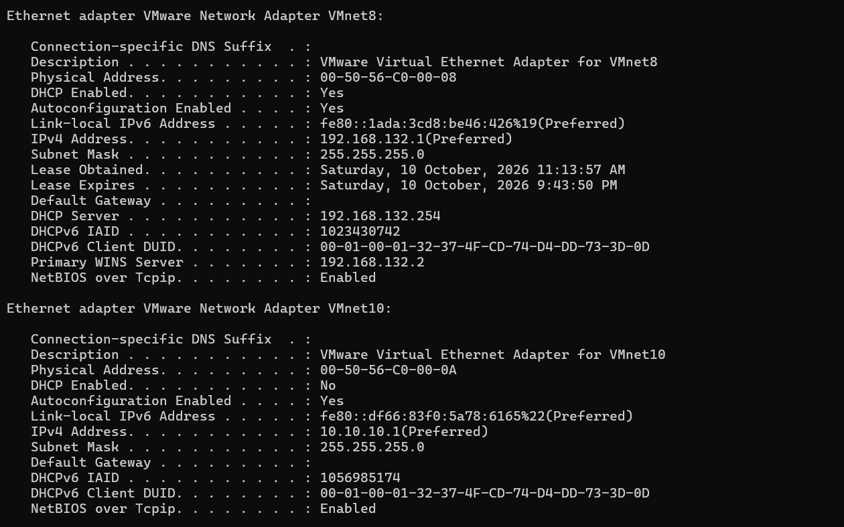

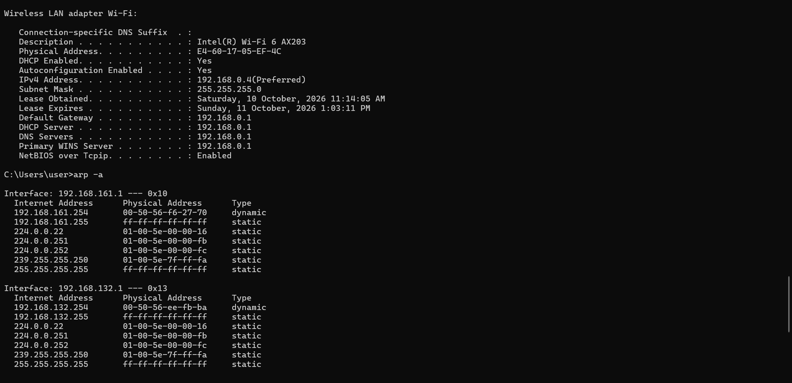

This output displays the full network configuration for all active and virtual network adapters on our system. It provides key details such as our active Wi-Fi IPv4 address (192.168.0.4), MAC address, default gateway (192.168.0.1), and VirtualBox/VMware network settings.

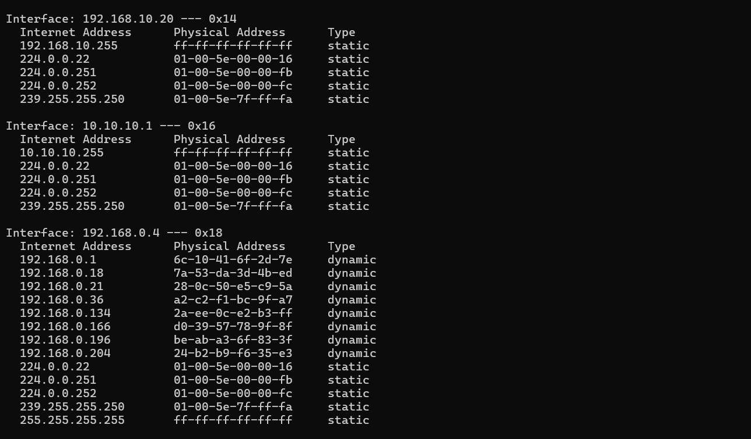

This output lists the current ARP cache entries, showing IP-to-MAC address mappings for local devices. It reveals 8 active dynamic neighboring hosts on our Wi-Fi subnet (192.168.0.4), which helps map out live devices sharing the same local network segment.

Q15. What network range (subnet) can you work out from your IP and mask? How many hosts could exist in it?

Answer: With an IP address of 192.168.0.4 and a subnet mask of 255.255.255.0 (/24), the network range (subnet) is 192.168.0.0 to 192.168.0.255. A /24 subnet provides $256$ total IP addresses ($2^8$), but since $1$ is used for the network ID (192.168.0.0) and $1$ for the broadcast address (192.168.0.255), there can be a maximum of 254 usable hosts in this network.

Q16. How could an attacker use the ARP table? How is it different from a DNS lookup?

Answer: An attacker who gains local access can inspect the ARP table to map out active devices sharing the same local subnet (showing IP-to-MAC address mappings). This allows them to discover potential target machines or perform MITM (Man-in-the-Middle) attacks like ARP poisoning/spoofing. It differs from a DNS lookup because DNS translates human-readable domain names to IP addresses over a network, while ARP maps IP addresses to physical hardware (MAC) addresses strictly within the local Ethernet/Wi-Fi network segment.
  - : Host and user enumeration Steps (Command Prompt):
    - systeminfo | findstr /B /C:"Host Name" /C:"OS Name" /C:"OS Version" /C:"System Type" /C:"Domain"
    - whoami /groups
    - net user
    - net localgroup administrators
    - net share
Show and explain the results. (You may blur your username in screenshots if you wish.)

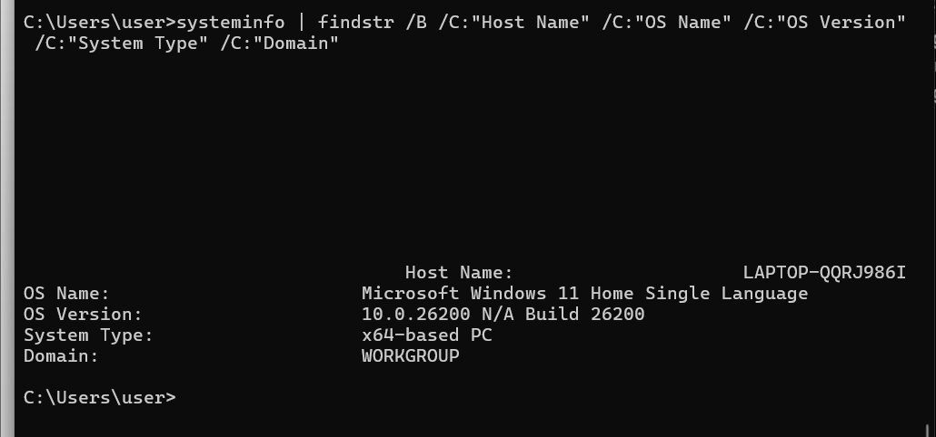

- This output filters key local system specifications, showing our host name (LAPTOP-QQRJ986I), exact OS version (Windows 11 Home Build 26200), system architecture (x64-based PC), and workgroup domain. Gathering these details helps identify the exact operating system build and architecture to check for known system vulnerabilities

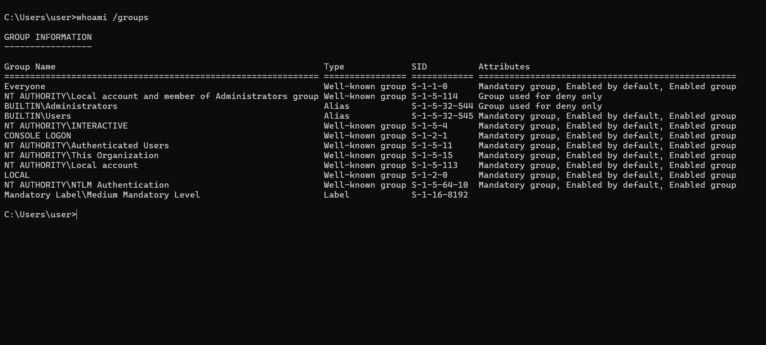

- This output checks the group memberships and privilege levels associated with our current user session. It shows that our account belongs to standard local groups as well as administrative privileges (BUILTIN\Administrators), operating under a Medium Mandatory Level.
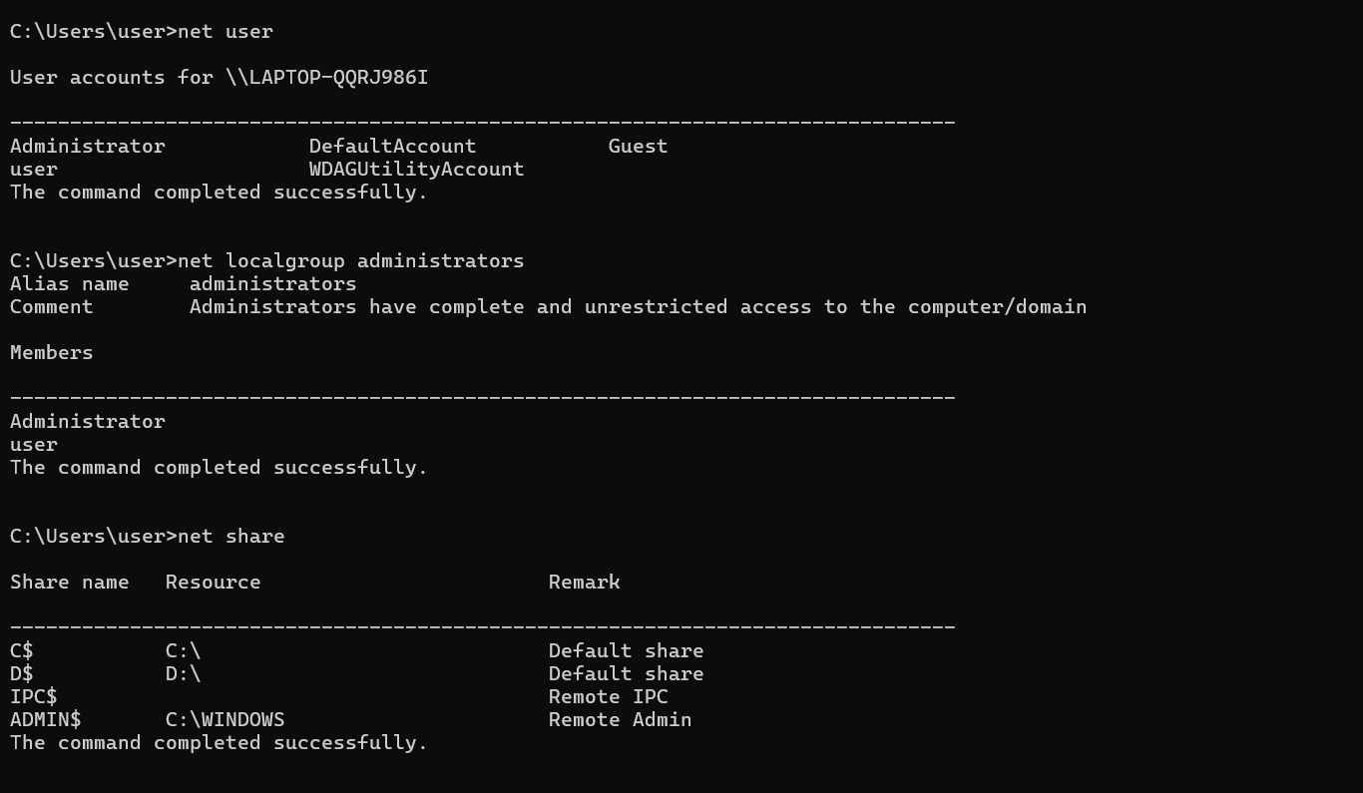

- These commands list all local user accounts, high-privilege administrative members, and shared network resources on the system. The output reveals that both Administrator and user belong to the local administrators group, while displaying default administrative shares like C$, D$, and ADMIN$. This information helps identify potential privileged targets and exposed network paths on the local machine.

Q17. Which of the information from systeminfo helps an attacker choose an exploit? Why? Answer: The OS Name (Microsoft Windows 11 Home Single Language), OS Version (10.0.26200 Build 26200), and System Type (x64-based PC) are the most critical pieces of information for an attacker. This is because knowing the exact OS build and system architecture allows an attacker to search public exploit databases (such as Exploit-DB or CVE databases) for known, unpatched vulnerabilities that specifically target this build.

Q18. Why is it valuable to know the local administrators and network shares? Name two defences.

Answer: Knowing who the local administrators are (Administrator and user) helps an attacker identify high-privilege targets for account takeover or credential spraying attacks. Identifying network shares (like C$, D$, and ADMIN$) reveals exposed internal folders and potential paths for lateral movement across the network. Two effective defences are:

Enforcing the Principle of Least Privilege: Restricting administrative rights so that standard accounts do not have full administrator access.

Disabling Default Administrative Shares: Restricting administrative and hidden network shares (such as C$ or ADMIN$) through Group Policy to prevent unauthorized lateral access.

TASK 4: Summary
Q19. What is the purpose of reconnaissance in cybersecurity, and why is it important before performing further security testing?

Answer: The main purpose of reconnaissance is to gather as much useful information and intelligence about a target system or network as possible before launching any security assessment. It is important because it helps us understand the target's environment, find potential weak spots, and plan our next steps efficiently without wasting time testing blind spots.

Q20. Based on the activities you completed, what types of information can be collected through reconnaissance, and how can this information help identify potential security risks?
Answer: Based on our lab activities, we can collect various types of information, including IP addresses, DNS records, public files via search engines, open ports, server banner versions, and local system configurations. This information helps identify security risks because exposed software versions or open ports can reveal known vulnerabilities, while misconfigured domain records or user privileges can expose the organization to phishing, unauthorized access, or exploits.

